Social Media material
This is a social media package is to promote the global student survey “Educating towards forest-related Employment”. The survey is run by the EFI-IFSA-IUFRO joint project “Global students networking and Green Jobs in the forest sector”.
The surveys aim is to gain a better understanding of the employment-related ambitions and perception of necessary skills/competencies. With the target audience being students and recent graduates of forest-related programs around the globe.
The survey is currently available in Chinese (simple), English, French, Portuguese (Brazil) and Spanish, the language can be changed via a menu is the top right-hand corner of the survey. Version in Mandarin to follow soon.
It is also possible to pause the survey by clicking “Save and continue later” if it is not possible to fill in the full survey in one sitting.
The survey will be open for response until mid-October.
Please feel free to share the survey within your own networks and help us reach as many students and recent graduates of forest-related programs as possible.
If you have any further questions, need additional materials for sharing or have an idea for spreading the survey please don’t hesitate to contact: Lisa.prior@efi.int

Content:
1) Twitter handles for partner organization in the project: 2
2) Social cards (images): 2
3) Banner 5
4) Links and QR-code: 6
5) Suggested post texts: 6
6) Social cards (Portuguese) 7
7) Social cards (Spanish) 8
8) Social cards (French) 9
9) Social cards (Chinese (simple)) 10

Twitter handles for partner organization in the project:
@efiresilience
@IFSAdotnet
@IUFRO

Social cards (images):
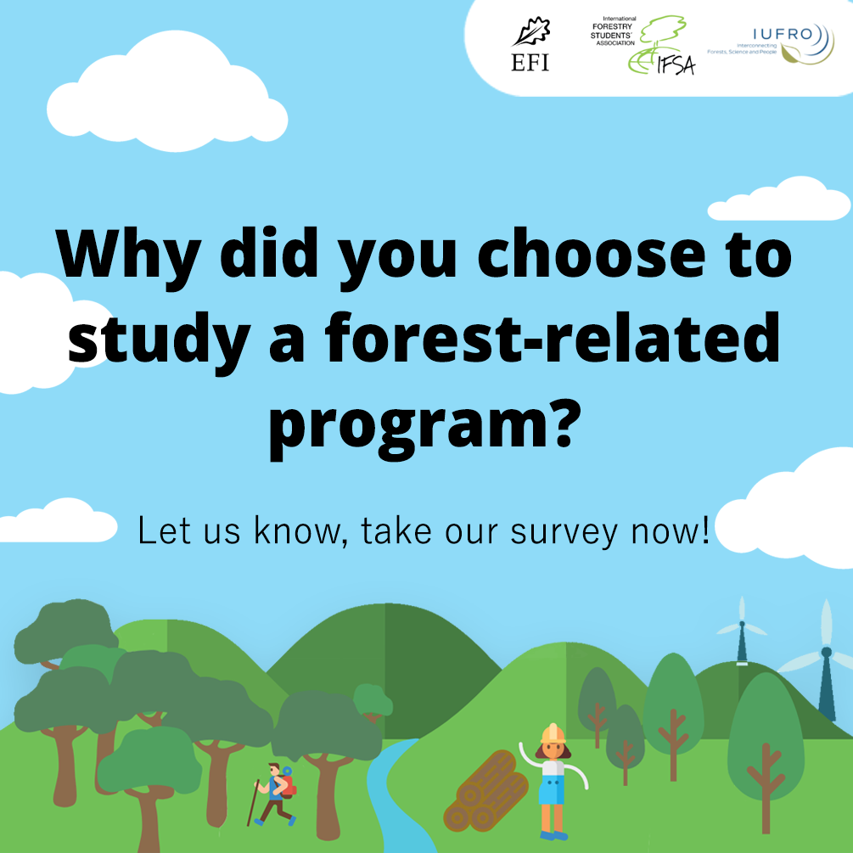
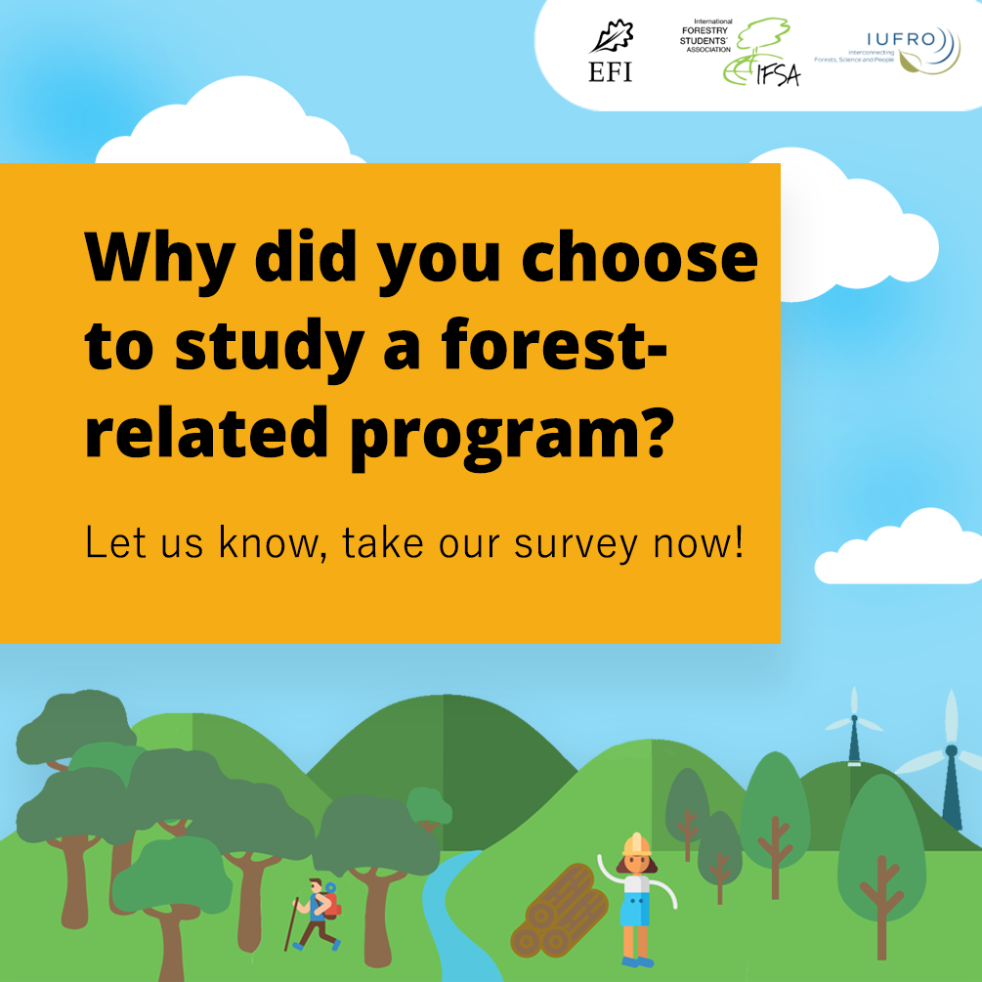
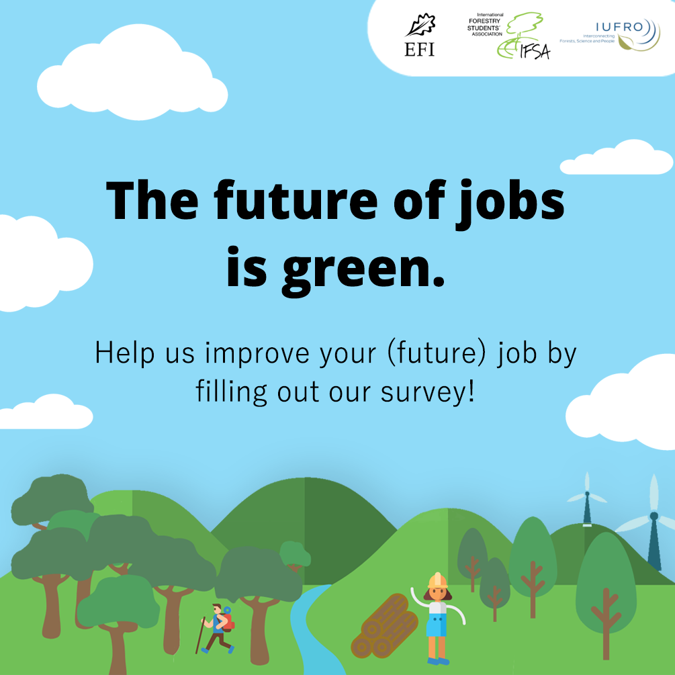
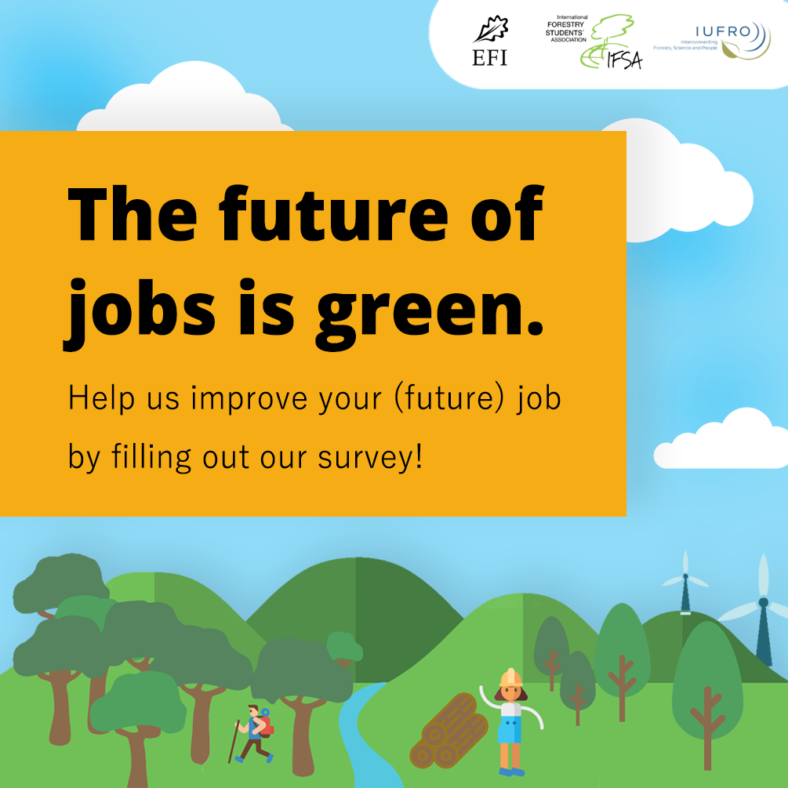
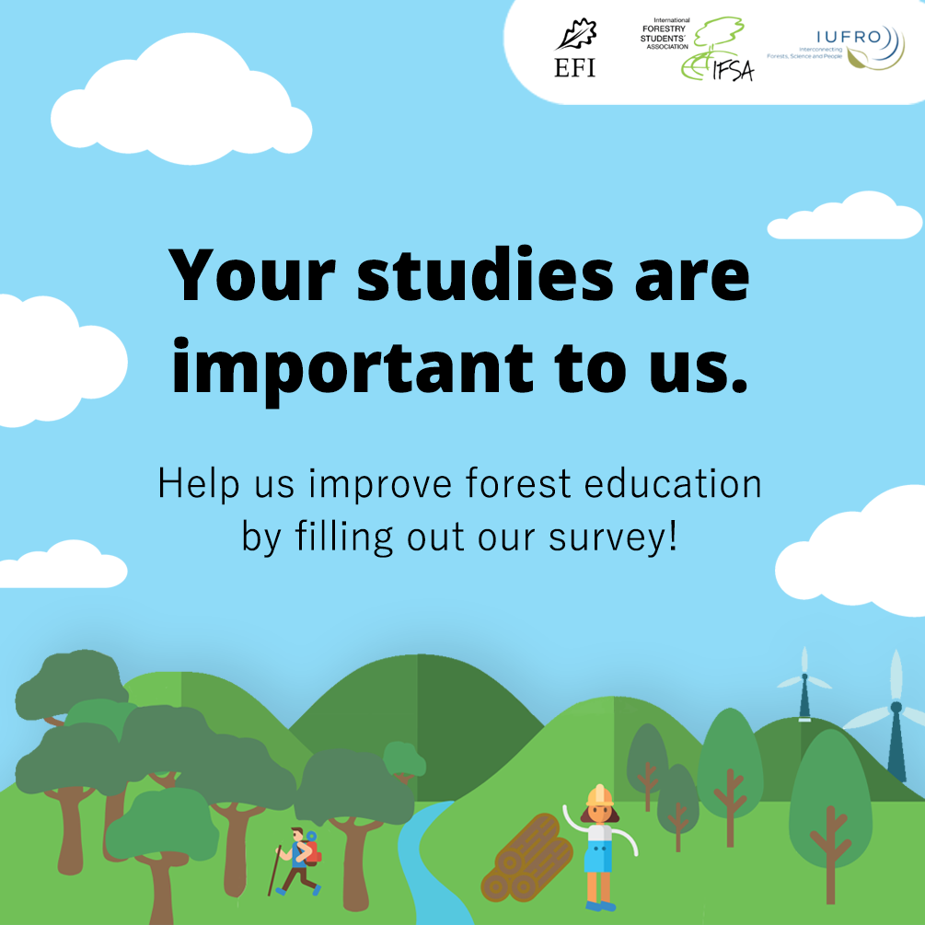
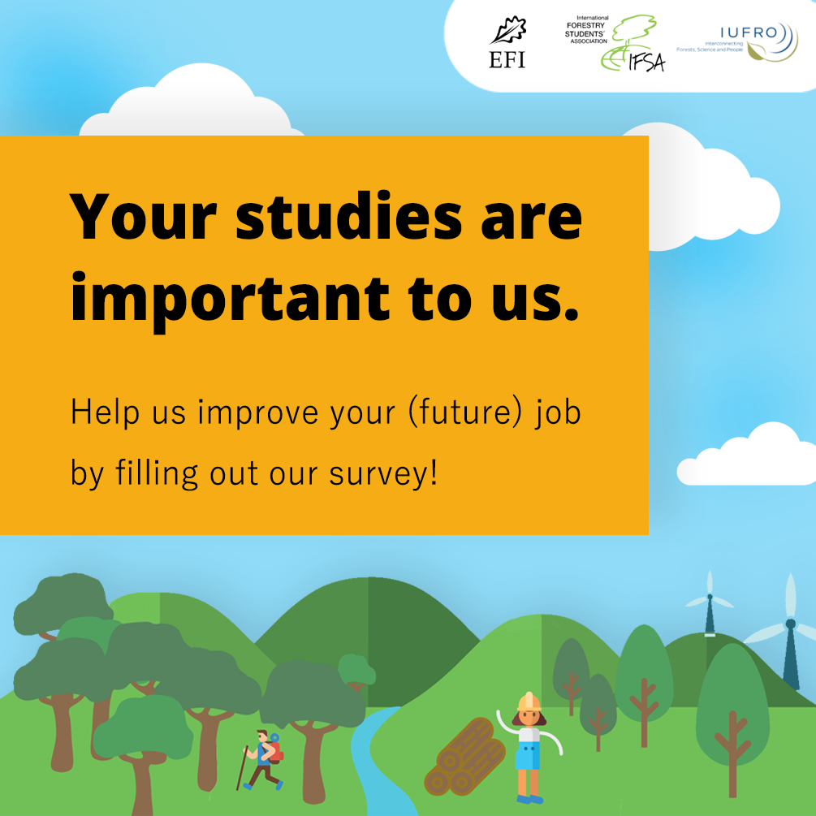

Banner

Links and QR-code:
Survey: https://www.surveygizmo.eu/s3/90242538/Educating-towards-forest-related-employment
Further information survey: https://ifsa.net/efi-ifsa-iufro-project/global-student-survey/
Overall project page: https://ifsa.net/efi-ifsa-iufro-project

Chinese (simplified): https://www.surveygizmo.eu/s3/90242538/77beb64d9ed1
English: https://www.surveygizmo.eu/s3/90242538/Educating-towards-forest-related-employment
French: https://www.surveygizmo.eu/s3/90242538/363d3fdf86b5
Portuguese (Brazil): https://www.surveygizmo.eu/s3/90242538/33bf673736ec
Spanish: https://www.surveygizmo.eu/s3/90242538/817403b2c87d

Suggested post texts:
- The #GreenJobs project by @efiresilience t @IFSAdotnet and @IUFRO is asking: What do #students in #forestry and related sciences expect from their future #career? Take part in the survey and shape your future: https://surveygizmo.eu/s3/90242538/Educating-towards-forest-related-employment
- Help the team of the #GreenJobs project by @efiresilience @IFSAdotnet and @IUFRO and take their survey now [https://surveygizmo.eu/s3/90242538/Educating-towards-forest-related-employment]
- What do current students expect from their future career in the forest-related sector? This is one of the questions addressed by the “Global Students Networking and Green Jobs in the forest sector” project in their recently launched global survey “Educating towards forest-related employment” among students and recent graduates of forest-related higher education programs.

Social cards (Portuguese)
Portuguese (Brazil): https://www.surveygizmo.eu/s3/90242538/33bf673736ec
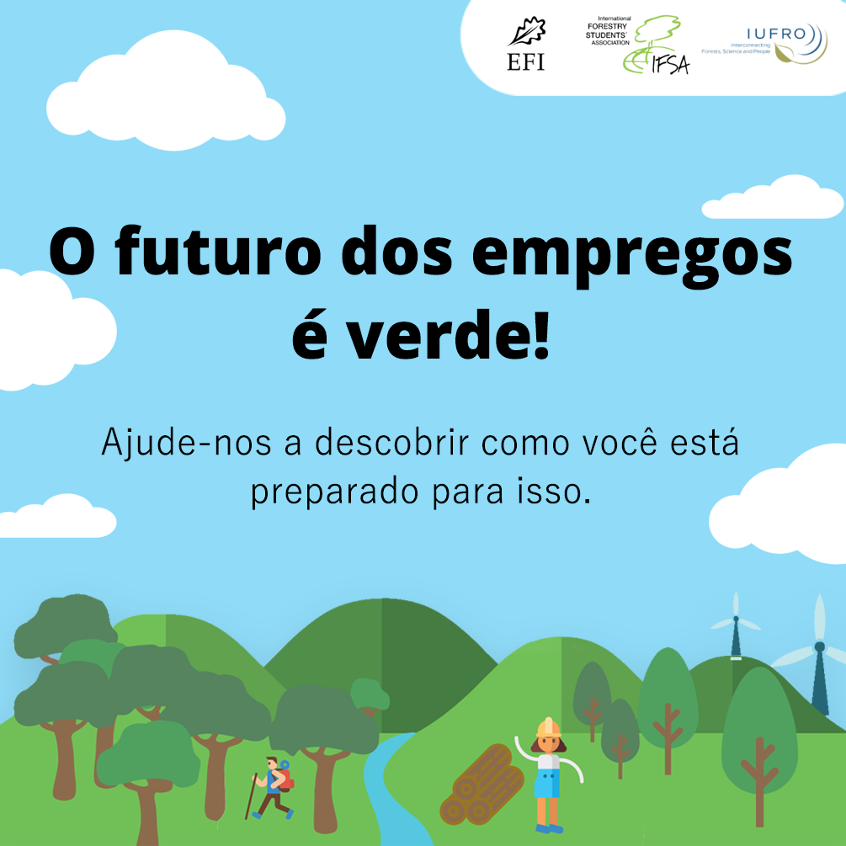
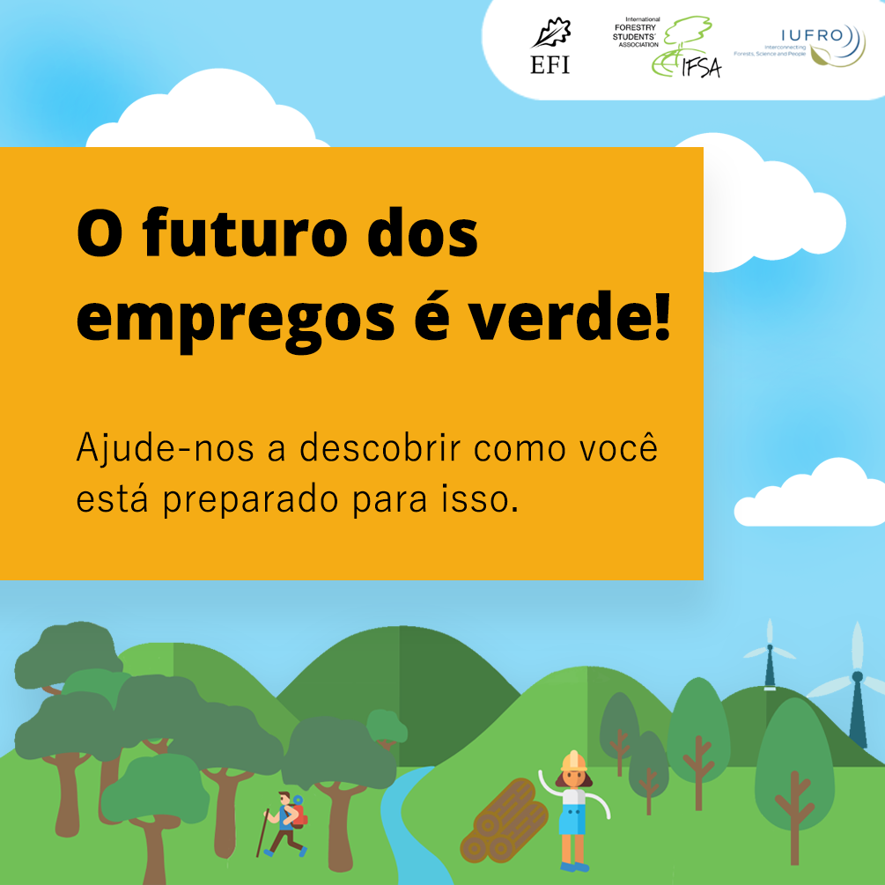

Social cards (Spanish)
Spanish: https://www.surveygizmo.eu/s3/90242538/817403b2c87d
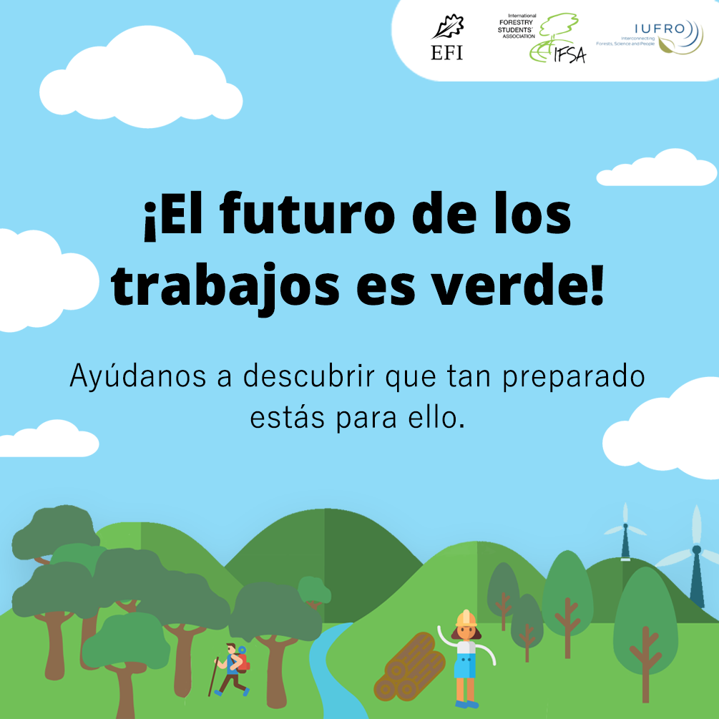
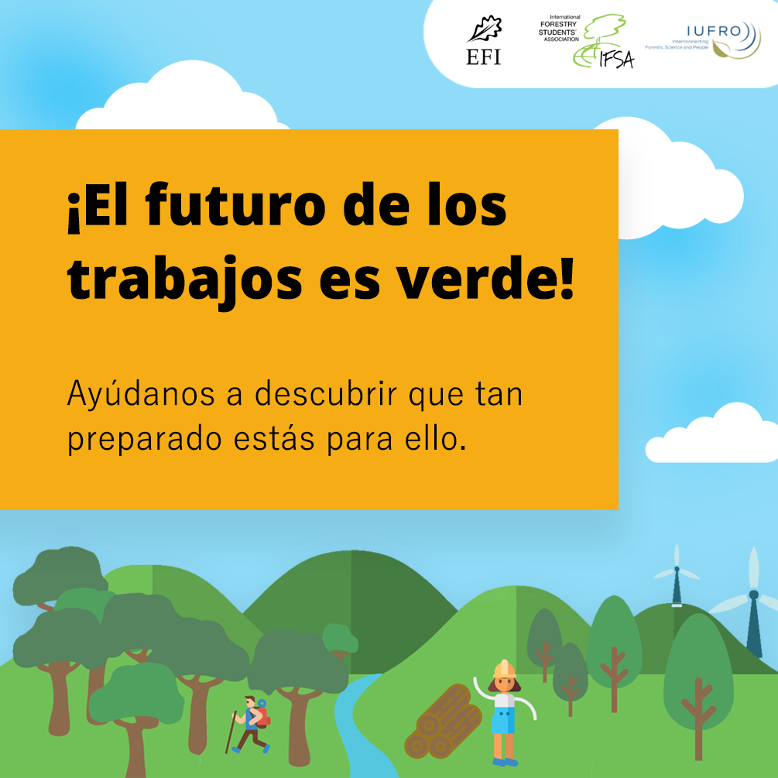

Social cards (French)
French: https://www.surveygizmo.eu/s3/90242538/363d3fdf86b5
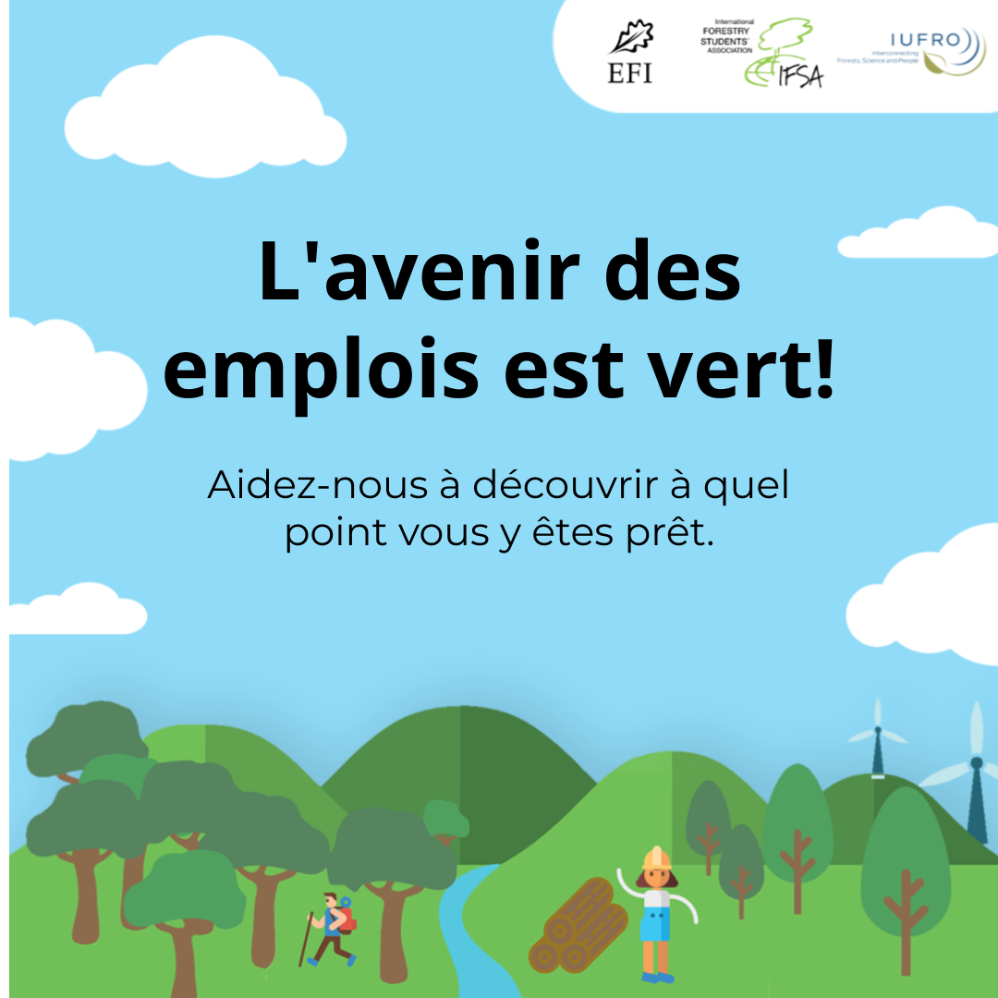
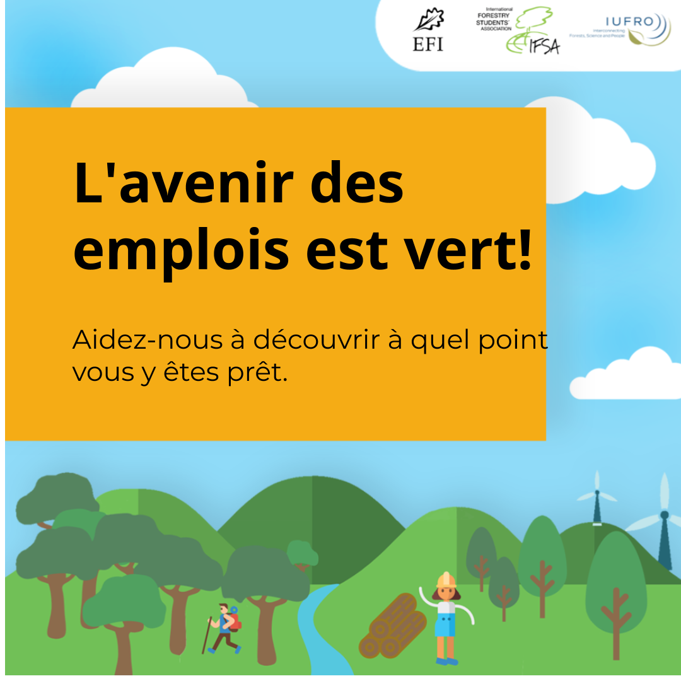

Social cards (Chinese (simple))
Chinese (simplified): https://www.surveygizmo.eu/s3/90242538/77beb64d9ed1
